SCUBA-2 Block Specification
Dispatch

Created on: 4 October 2005
Last saved on: 01 November 2005
Table of Contents

1. Block Description 3
1.1 Block Hierarchy 3
1.2 Block Overview and Features 3
1.3 Detailed Description 3
2. Interface Description 4
2.1 Signals Description 4
2.2 Protocol / Interface Timing 5
2.2.1 Receiving a command 5
2.2.2 Executing a command 5
2.2.3 Sending a reply 5
2.2.4 Resetting the watchdog timer 5
3. Dataflow Description 6
3.1 Dispatch (Top Level) 6
3.2 Dispatch_cmd_receive 7
3.3 Dispatch_wishbone 7
3.4 Dispatch_reply_transmit 8
4. State Machine Description 9
4.1 Dispatch (Top Level) 9
4.2 Dispatch_cmd_receive 10
4.3 Dispatch_wishbone 11
4.4 Dispatch_reply_transmit 12
Files Associated With This Block 13

Block Description

Block Hierarchy
(Any) Card Top-Level
Dispatch
Wishbone Slave 0
Wishbone Slave 1
Wishbone Slave 2
Wishbone Slave n
To Bus Backplane
From Bus Backplane
Hardware
Hardware

Hardware

Hardware

Block Overview and Features
The dispatch receives commands sent by the issue_reply module, executes them, and then sends the replies back to issue_reply. Note that only one command at a time can be processed by the dispatch module.
The dispatch module also implements a Wishbone interface master; the Wishbone protocol is used to connect the various functional units (which do the actual execution of the command) together.

Detailed Description
A command arrives at the dispatch via a serial LVDS link from the clock card over the bus backplane. The data is deserialized by a lvds_rx module and its content analyzed by the dispatch_cmd_receive module. If the command arrives with invalid fields or invalid checksum (CRC-32), the packet is discarded and an error message is sent back to the clock card. If the packet arrives with an invalid preamble, the receiver assumes that it is out of sync with the transmitter and waits until a packet with a proper preamble is received, thus restoring synchronization. No error packet is sent back in this case, as synchronization/timeout errors are handled by the issue_reply firmware (see documentation for issue_reply).
If the command arrives without problems, the contents of the command are forwarded to the dispatch_wishbone module for execution. The command is executed and the results are stored in a buffer. A signal is asserted when the command has finished executing that signals the dispatch_reply_transmit module to begin sending the reply.
The reply to the command is then assembled into bus backplane packet format and sent over the bus backplane by the lvds_tx module inside dispatch_reply_transmit. Dispatch_reply_transmit is also responsible for calculating the new CRC checksum and appending it to the reply packet.

Interface Description

Signals Description
 | Description | Direction
Global Signals
clk_i | Global 50 MHz system clock. | in
comm_clk_i | Global 200 MHz communications clock. Used by lvds_rx for sampling the input LVDS signal. | in
rst_i | Global reset signal. | in
Bus Backplane Interface Signals
lvds_cmd_i | Input LVDS signal. The command from the clock card arrives on this signal. | in
lvds_reply_o | Output LVDS signal. The reply to the clock card is transmitted on this signal. | out
Wishbone Interface Signals
dat_o | Data output bus. Data from the wishbone master is sent to the slave over this bus. | out
addr_o | Address bus. An address on this bus corresponds to a particular wishbone slave. | out
tga_o | Address Tag bus. Used to indicate the destination address for the data on dat_o. | out
we_o | Write enable signal. When asserted, tells the slave that the current bus cycle is a write cycle. | out
stb_o | Strobe signal. When asserted, tells the slave that the data on dat_o is valid. | out
cyc_o | Cycle enable signal. When asserted, tells the slave that a wishbone bus cycle is in progress. | out
dat_i | Data input bus. Data from the wishbone slave is sent to the master over this bus. | in
ack_i | Acknowledge signal. Asserted by the slave when the data on dat_o has been latched or when the data on dat_i is valid. | in
err_i | Error signal. Asserted by wishbone bus logic if an address on addr_o does not correspond to any slave. | in
Miscellaneous External Interface Signals
wdt_rst_o | Watchdog timer reset signal. When not asserted periodically (ie. due to a problem in executing a command), the external watchdog timer will cause the system to reset automatically. | out
slot_i | Slot ID input. This signal is hardwired to a constant value which varies from slot to slot. Dispatch uses this signal to determine what card it is and thus which commands it needs to act on. | in

Protocol / Interface Timing

Receiving a command

Executing a command

Sending a reply

Resetting the watchdog timer

Dataflow Description

Dispatch (Top Level)
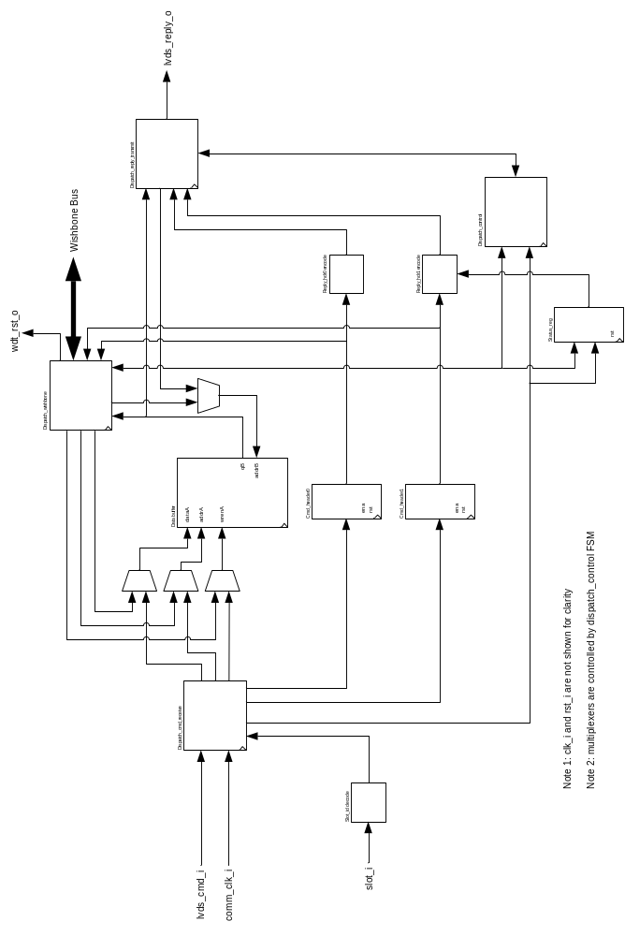

Dispatch_cmd_receive

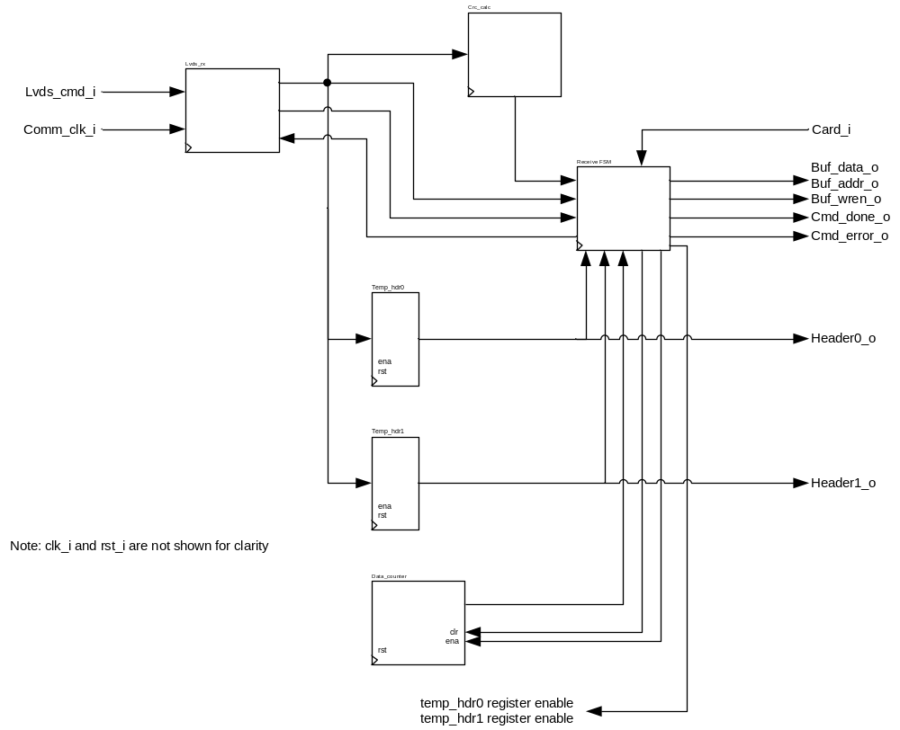

Dispatch_wishbone

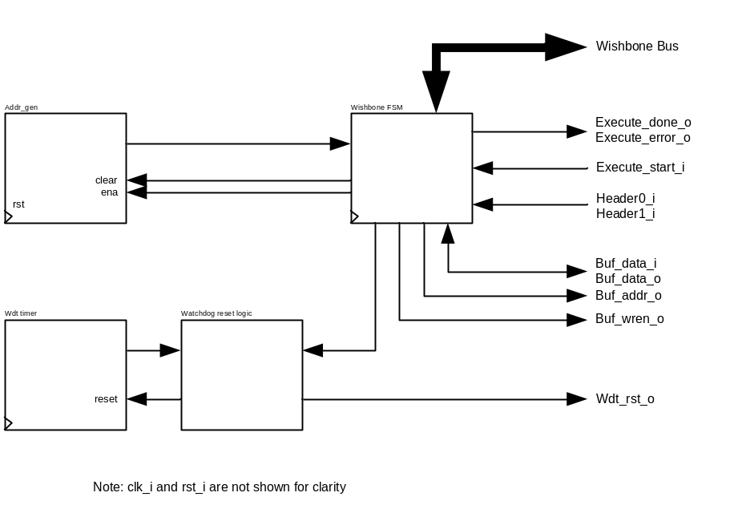

Dispatch_reply_transmit

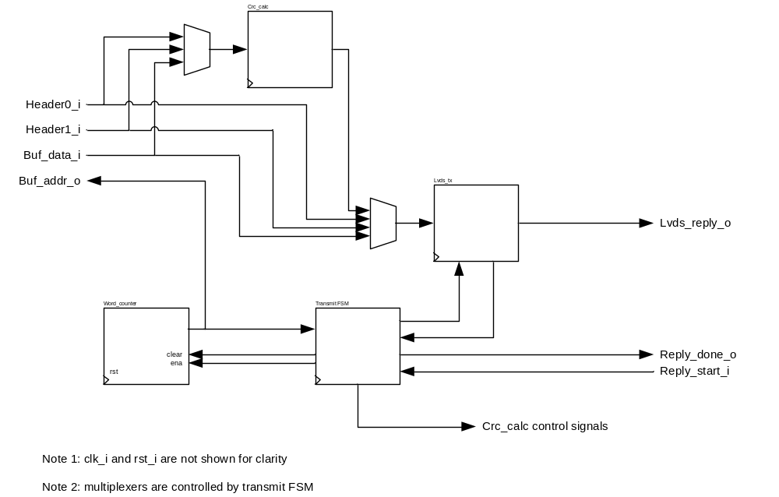

State Machine Description

Dispatch (Top Level)
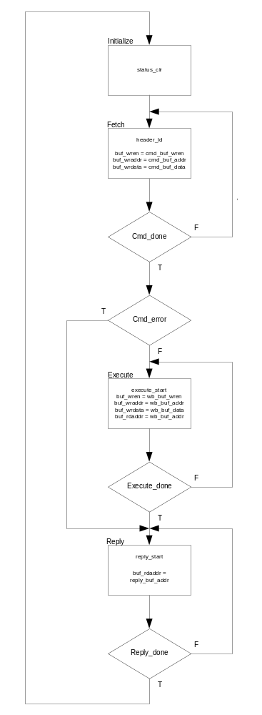

Dispatch_cmd_receive
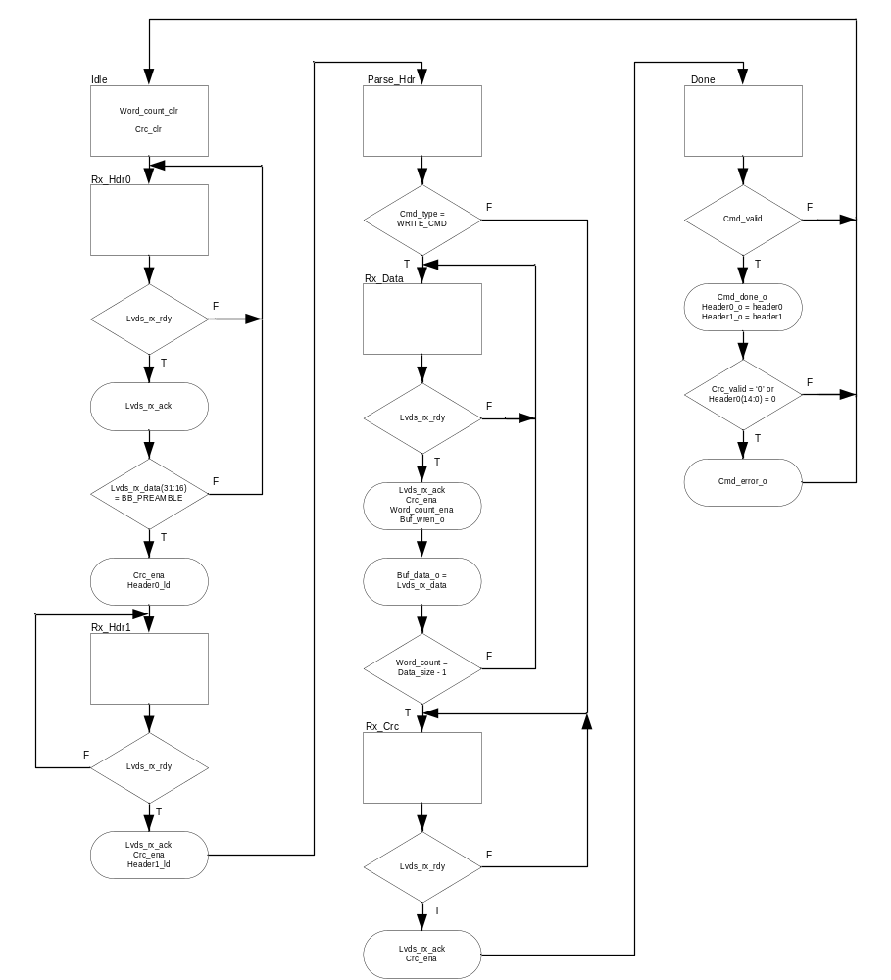

Dispatch_wishbone
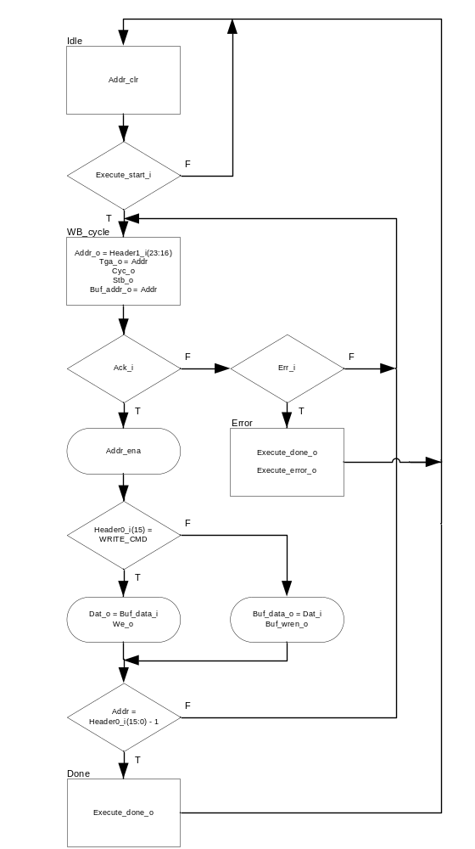

Dispatch_reply_transmit
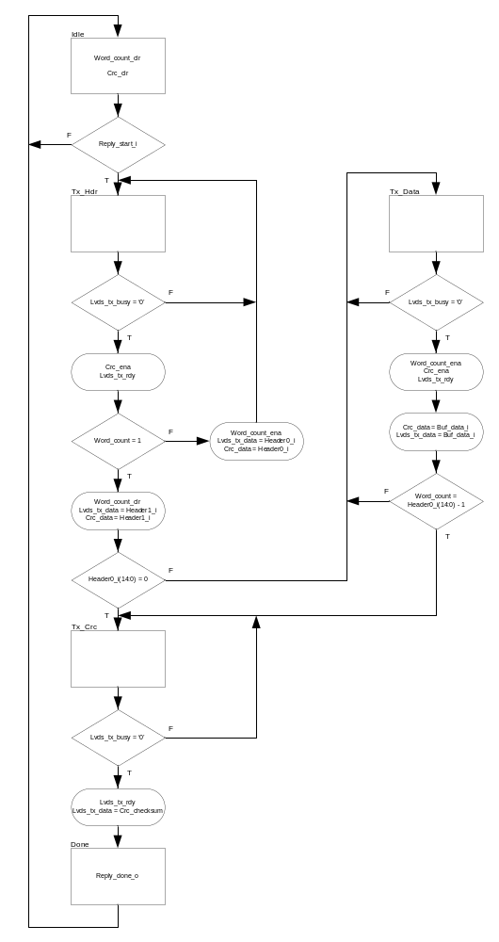

Files Associated With This Block

File | Description
dispatch.vhd | Top-level of dispatch module.
dispatch_cmd_receive.vhd | Implements the bus backplane receiver and command packet decoder.
dispatch_reply_transmit.vhd | Implements the bus backplane transmitter and reply packet encoder.
dispatch_wishbone.vhd | Implements the wishbone master.

